Fractal Landscape
- Computer games today are incredibly complex believable game object elements, intelligent, challenging and addictive game play to its players.
- As game universes become more complex — more worlds, more buildings, more rooms, with more polygons, textures, characters and so on — the man-hours required to design and model them grow exponentially.
Hiring game artists becomes a very expensive exercise

- As game worlds grow larger, so do the data files storing the game information; game map designs, character models etc.. The amount of game data to store the game information has expanded in game file sizes throughout computer game history
- Example: Castle Wolfenstein install file(1983) = 69kb but Return to Castle Wolfenstein (2001) demo install file = 114.1 MB
- How to solve this problem : Procedural terrain generation
Procedural Terrain Generation
Procedural terrain generation is about making optimal use of system bandwidth and main memory by dynamically generating lower-level geometry data from statically stored higher-level scene data.
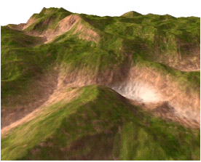

Different Approaches to Procedural Generated Terrain
Some of the procedural methods used in contemporary games include:
    - Fractal landscape
    - Perlin Noise
    - L-systems
A way to create this fractal landscape is to employ random midpoint displacement algorithm, in which a square is subdivided into four smaller equal squares and the center point is vertically offset by some random amount. The process is repeated on the four new squares, and so on, until the desired level of detail is reached.
Another method is to subdivide and perturb as shown below
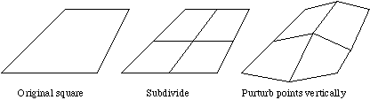

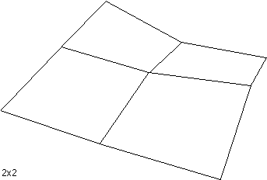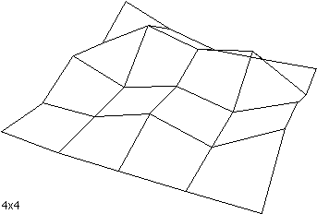

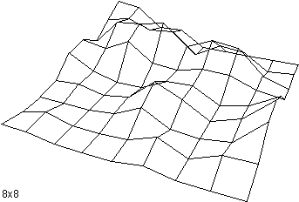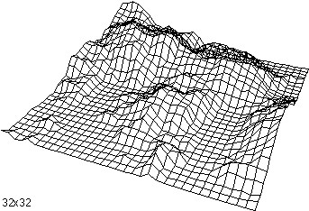

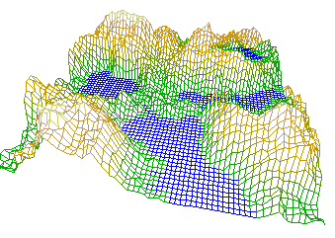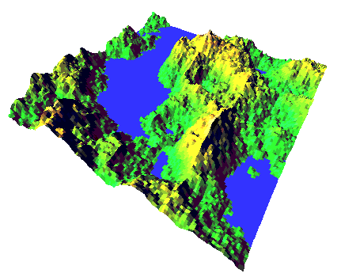

Perlin Noise
Developed by Ken Perlin to create textures
This is a function which uses interpolation between a large number of pre-calculated gradient vectors to construct a value that varies pseudo-randomly over space and/or time to create textures
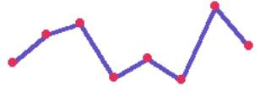
Linear Interpolation Cosine Interpolation

Two-dimensional Perlin noise

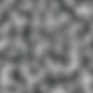

Procedural Salt and pepper noise
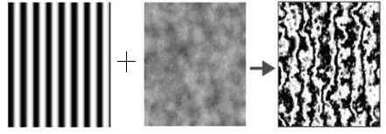

Procedural marble texture
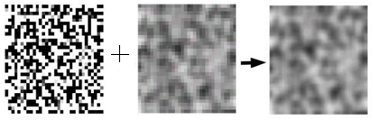

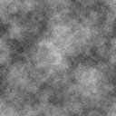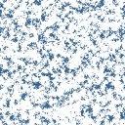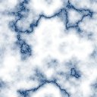
Perlin Noise is the mother of all procedural textures and can be used to create a variety of natural textures like rock, marble, soil and clouds.

Write Algorithm for midpoint displacement method and implement in Excel
Show the running of VB code for random terrain generation
Convert VB code file into exe and store

References
1: http://www.vterrain.org/Elevation/Artificial/ Artificial terrain generation
2. http://terraineer.sourceforge.net/ Terraineer – an opensource toolkit
3. http://www.gameprogrammer.com/fractal.html Generating random fractal
terrain
4. http://mrl.nyu.edu/~perlin/ Homepage of Perlin
5. http://www.drdobbs.com/architecture-and-design/222600097 Perlin noise on
Cuda

